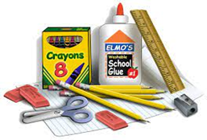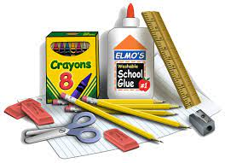

**Winterset Elementary**

**2025-2026 Supply List**

**Specialized Learning Center Classrooms**

**Kdg – 1st Grade 2nd-5th Grade**

6 large pencils 24 pencils Ticonderoga (preferred)

8 pack large crayons 24 pack Crayola crayons

**All grades Kdg – 5th Grade**

8 glue sticks

Scissors

Set of headphones for computer use

4 boxes Kleenex

3 SOLID colored 2 pocket folders (with nothing written on them)

2 packages of antibacterial wipes (such as Lysol, etc.)

A complete change of clothes to keep at school

Toileting supplies if your child needs toileting assistance

(diapers/pullups and wipes)